Terraform Task-2

Task Description:

Create 2 EC2 instances on 2 different regions and install nginx using terraform script.

Techstacks needs to be used :

AWS EC2
Terraform
AWS CLI

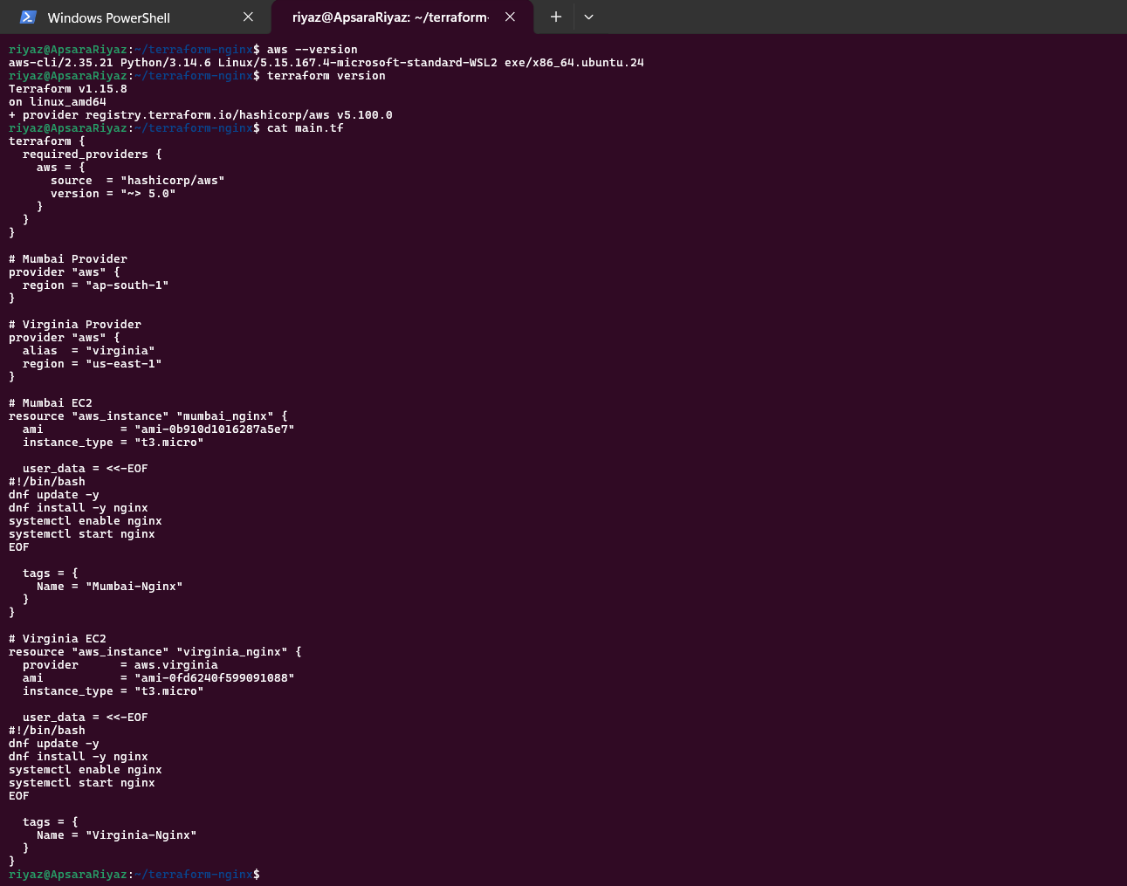
EC2- Mumbai Nginx
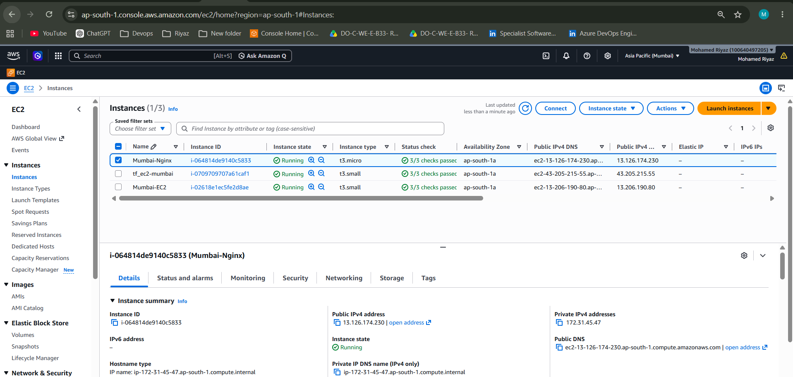
EC2-Viginia- Nginx
